D2L Analytics

Content (Main Navbar)

Statistics

Table of Contents (TOC) > Related Tools drop-down menu to select View Reports.
  - Statistics option opens by default to display Content or Users tab data. The Export Statistics allows you to download a CSV file. Reset Statistics does not reset the student completion status of content topics visited but rather resets the number of visits to and time spent in each content topic.
    - Content tab (Note: the information collected is from the any items added via the New button or Add Existing Activities):
      - Total Number of Users visited, Users Who Have Visited Content, and Average Time Spent on Content (entire class)
        - Available To column: Number of users that the module is available to.
        - Users Visited column: Number of users who visited one or more topics in a module. Find data for each student regarding last date visited, Number of Visits, Total Time Spent, and Average Time.
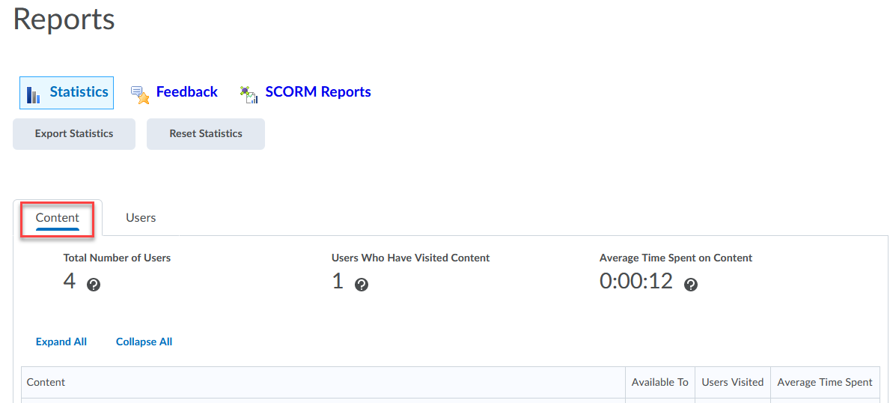
    - Users tab
      - Lists student names and number of content topics visited.
      - Search for an individual student or group by entering the name in the search box and Enter or select magnifying glass.
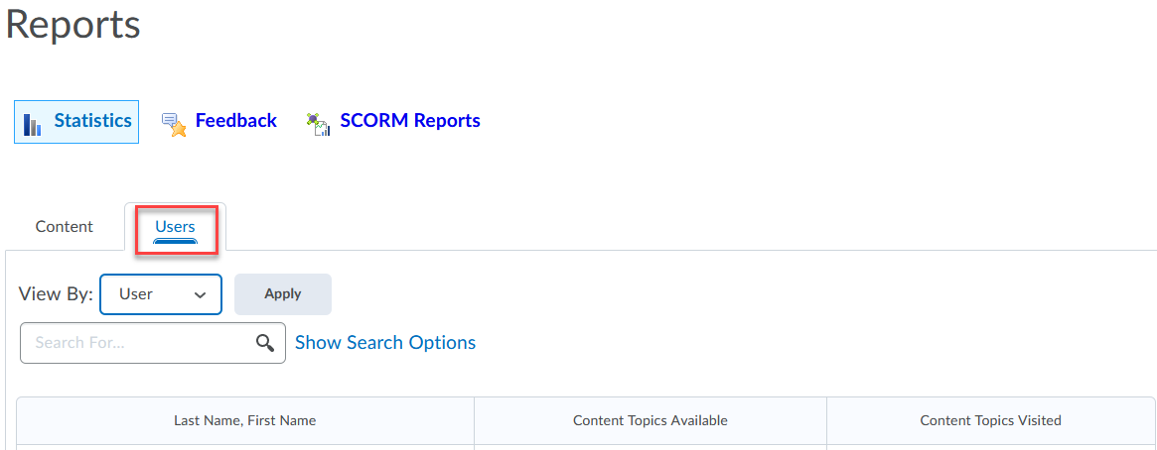

Classlist (Main Navbar)

Enrollment Statistics
  - Find total number of enrollments and withdrawals for all roles listed in the Classlist.

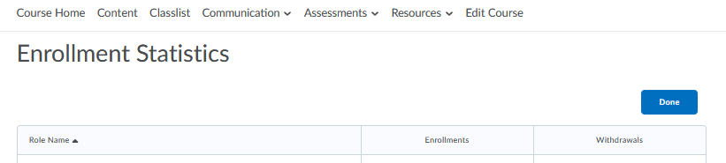

Discussions (Communication – Main Navbar)
- Statistics
There are two tabs found under Statistics. (Users tab is the default.) The Export to CSV file allows you to download a copy.
  - Users tab (filter by user or group)
    - Org Unit Statistics summary:
      - Total Threads (All Forums)
      - Total Replies (All Forums)
      - Unapproved Posts
    - User Statistics:
      - Number of threads
      - Number of Replies
      - Number of read posts (including own)
      - Number Unapproved posts
      - Number of Posts scored
    - Forums and Topics (Org Unit Statistics Summary):
      - Total Threads (All Forums)
      - Total Replies (All Forums)
      - Number of Pinned Threads
      - Number of Unapproved Posts
    - Forum and Topic Statistics
      - View the statistics at the forum/topic level:
        - Number of Threads
        - Number of Replies
        - Number of Pinned Threads
        - Number of Unapproved Threads
        - Number of Scored Threads
        - Post Ratings (Up, Down, Star)
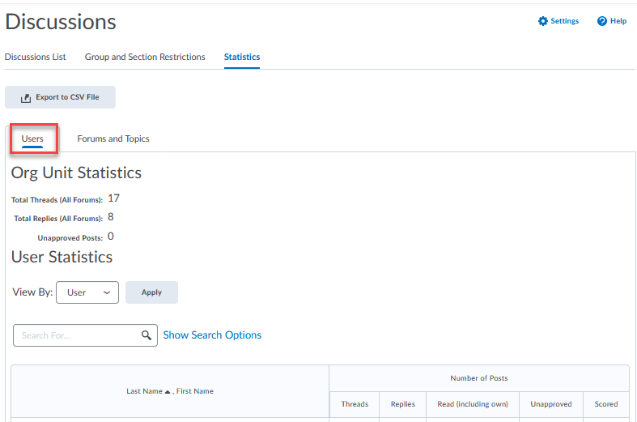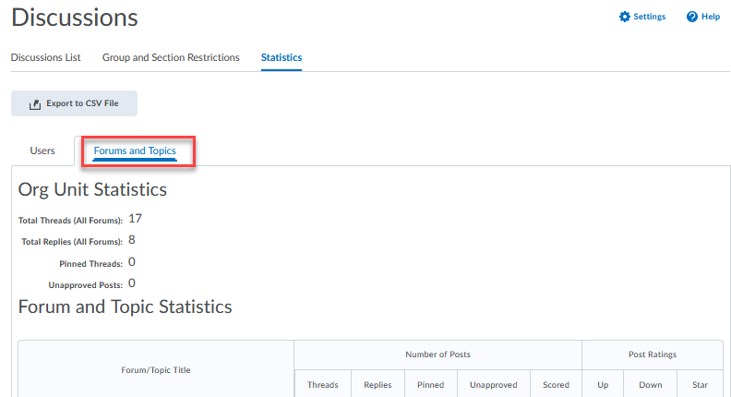

Dropbox (Assessments – Main Navbar)

- Submission Log
  - Located in the drop-down menu for a dropbox folder.
  - Listing of date/time stamp of student submissions.
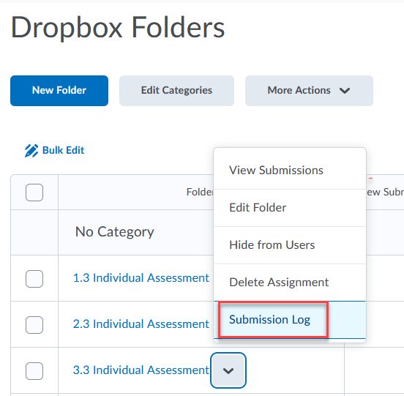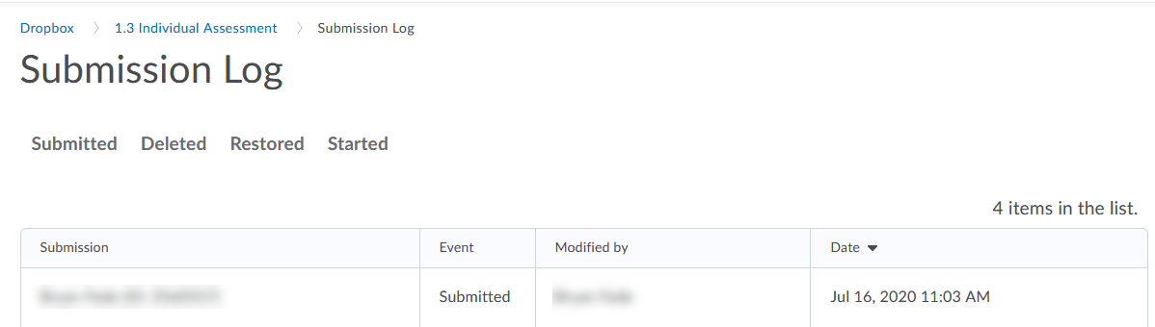

Quizzes (Assessments – Main Navbar)
- Statistics (Based on student’s first quiz attempt.)
  - Filter by Category or Availability (Current vs. Past)
  - Quiz Averages for each Quiz is listed
  - Click on the Quiz name hyperlink to view User Stats, Question Stats, and Question Details tabs
    - User Stats tab
      - Export to CSV or Excel is available.
      - Displays Score Distribution and Class Average
      - Student listing and average grade.
      - Search by student name
    - Question Stats tab
      - Export to CSV or Excel is available.
      - Lists average grade along with standard deviation, discrimination index, point biserial for each question.
    - Question Details tab
      - Export to CSV or Excel is available.
      - Filter by date is available.
      - Each question is viewable including average grade, standard deviation, point biserial and discrimination index.
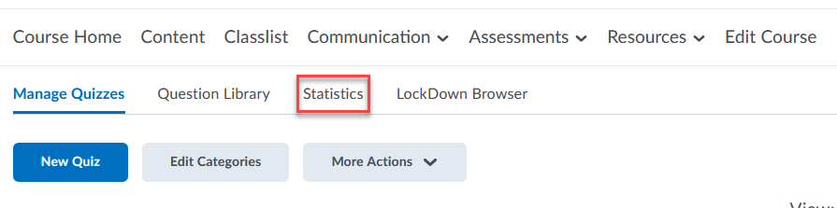

Edit Course (Main Navbar)
- Class Progress
  - Filter by All Users or Groups
  - Displays percentage of content completed, objectives, logins, and grades. (Note: Click on the hyperlink or icon to access more information, such as score.)
  - Click on student name to display progress summary.
  - Progress Reports are available for:
    - Summary – Grades: Number of grades received and whether or not final grade has been released; Objectives: Lists percentage of learning objectives passed; Content: Lists number of topics visits and time spent (percentage of completion of topics); Discussions – Number of posts read, number of threads created and replies posted; Dropbox: Percentage of dropbox submissions, number of late submissions, number of awaiting grade, average grade of assignment; Quizzes: Percentage of quizzes completed, attempts awaiting grade; Checklist: Percentage checklists completed, percentage of items completed; Surveys: Percentage of surveys completed; Course Access: Number of days visited and date of last access; Login History: Number of logins, date of last access
    - Grades – Lists grades of published grade items
    - Objectives – Percentage of learning objectives passed (Number of not started, in progress, passed and needs remediation)
    - Content – Number of topics visited, total visits, and time spent; percentage of content topic completion
      - Expand to view details of the content items
      - Conditionally Released icon present next to topics with release conditions.
    - Discussions – Number of posts read, threads created, and replies posted
      - Expand to view more details – topic and posts
    - Dropbox – Percentage of dropbox submissions, number of late submissions and awaiting grade, average of assignment grade
      - Expand to view details of student’s submission and feedback given
    - Quizzes – Percentage of quizzes completed and number of attempts awaiting grade
      - Expand to view details of quiz attempt and date of submission
    - Checklist – Percentage of checklists completed, and percentage of items completed
    - Surveys – Percentage of surveys completed
    - Course Access – Number of days visited over last 30 days and date of last access
    - Login History – Number of logins and date last accessed

