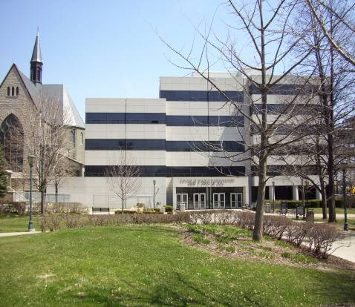
David A. Straz, Jr. Hall

Houses the College of Business Administration.

Accessibility

Entrances
West Entrance – automatic door, elevator through second set of automatic doors

(West view, arrow points north)

Women’s Bathrooms Men’s Bathrooms
Room 109 Room 110
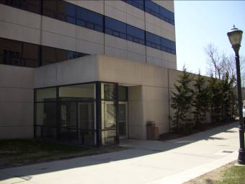
Room 119 Room 117
Room 264 Room 243
Room 364 Room 464

Next to Room 016 is handicap fountain

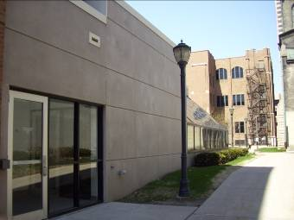

(North view)

(East view, Marquette Hall in background)

P.O. Box 1881
Milwaukee, WI 53201-1881
Office of the Dean (414)288.7142

