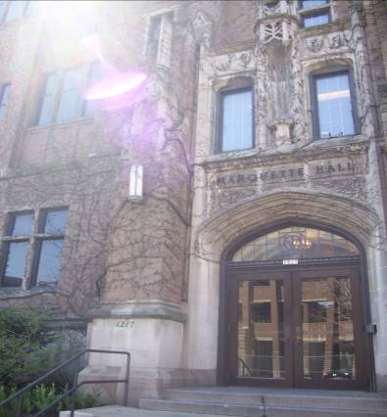
Marquette Hall

One of the most widely recognized buildings on campus; Marquette Hall is home to several offices, including Undergraduate Admissions on the first floor and Office of the Registrar on third floor.

Accessibility

Entrances
South Entrance – automatic door; elevator through doors
North Entrance – no automatic doors, stairs

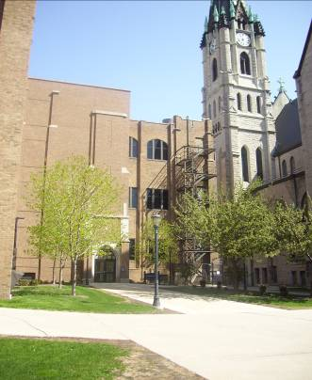

Women’s Bathrooms
Room 009
On 3rd floor, but not accessible (stairs)

Men’s Bathrooms
Room 011
On 3rd floor, but not accessible (stairs)

Elevator
Yes, 2; no key
Through south doors
Down hall from room 002

Marquette Hall
1217 W. Wisconsin Ave.
P.O. Box 1881
Milwaukee, WI 53201-1881
(414) 288-7034 | (414) 288-1773 (FAX)

