Financial Conflict of Interest (FCOI) Tutorial: Administrative Process

This process document is designed to accompany Marquette University’s Promoting Objectivity in Research/Financial Conflict of Interest policy which can be found at Policies and Guidance // Office of Research and Sponsored Programs // Marquette University.

WHO is required to take the training: The FCOI tutorial ONLY applies to investigators who receive funds from the United States Public Health Services (US PHS; includes NIH, HRSA, and SAMHSA, among others) or any other Sponsor requiring FCOI training (this may include the U.S. Department of Energy and PCORI, among others). “Investigator” refers to those individuals who are independently responsible for the proposed or actual design, conduct, and/or reporting of research for Covered Grants or Contracts. This may include Principal Investigators, Project Directors, Co-Investigators or any other individual who meets this definition.

WHEN: Identified individuals are required to take the training:
(1) Prior to engaging in any research, educational, or service activities being conducted under any Covered Grant or Contract, as of and following the effective date of the initial Policy.
(2) At least every four years.
(3) When a funded investigator on a Covered Grant or Contract is new to Marquette
University.
(4) Whenever this Policy is substantively amended.
(5) Whenever the Vice President for Research and Innovation has determined that an Investigator is not in compliance with this Policy or with any management plan or directive issued under this Policy.

PROCESS:

Identification
Covered Investigators are identified in multiple ways.

- Project Planning and Development team or Grants Administration team identifies individuals when Just in Time (JIT) information is requested from the sponsor.
- Grants Administration, Post-Award staff member establishing the account identifies individuals when establishing new accounts or non-competing continuations.
- Grants Assistant monitors master list to ensure that active researchers who have previously taken FCOI training retake it within four years of the initial/prior training to ensure continued compliance and that and new individuals are added.
- Vice President of Research and Innovation identifies individuals who are out of compliance with the FCOI policy or management plan who need to retake the training.

The identifying party will send an e-mail to the Grants Assistant, cc’ing postaward@marquette.edu
to request that the investigator be enrolled in the FCOI tutorial.

Enrollment
The FCOI tutorial can be found at https://d2l.mu.edu/d2l/home.The Grants Assistant is responsible ensuring that all covered investigators are enrolled.

New Investigator Enrollment – Not in D2L System
Upon identification of a new individual who must take the COI tutorial, the Grants Assistant completes the Person Training record in Kuali. This is done by selecting Common Tasks -> Person Training.

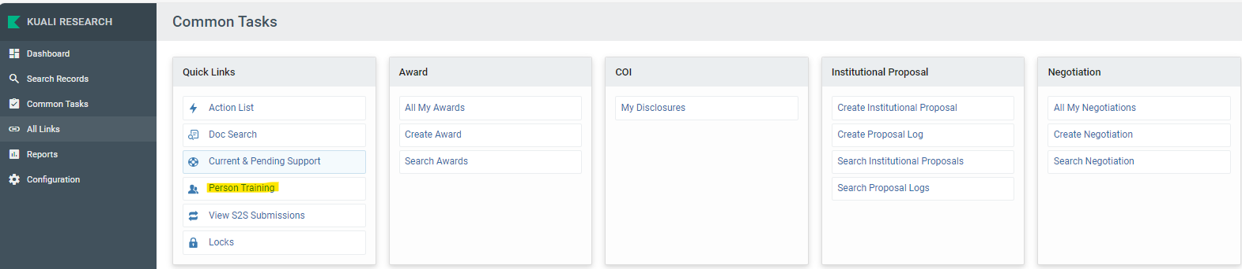

Click on the “create new” button in the upper right corner.
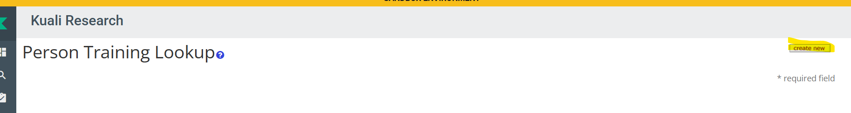

The following data elements are then entered:

KC Person = Covered Individual
Training = Financial Conflict of Interest
Add Date Requested = current date
Add Comment = FCOI training is required
Add check mark in Is Active
Click Submit

This will enroll the individual in the tutorial.
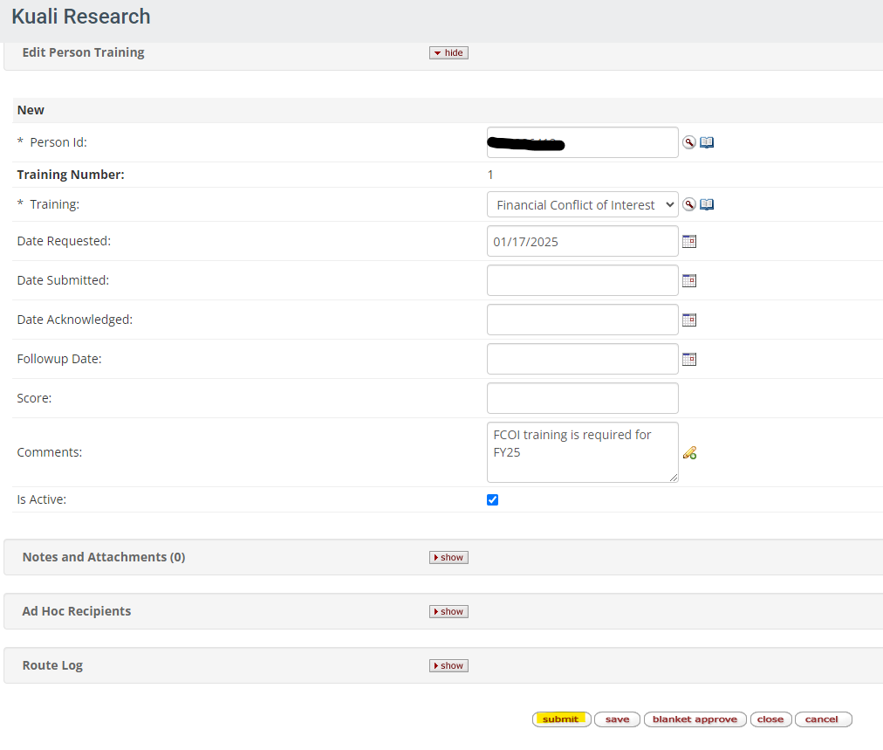

Renewal Investigator Enrollment
If an individual has already taken the COI tutorial, they will have continuous enrollment. When their training is 60 days from the expiration date, the system will send the individual an e-mail letting them know that the new version of the tutorial is available and specify the date by which it must be completed.

NOTE: if an individual takes the training more than 60 days prior to their Requested Date, the automation will not update the record in Kuali. Instead, an exception report will be sent to postaward@marquette.edu and the ORSP Executive Director. The Grants Assistant will see the report in the pos-award mailbox, then update the Date Requested in Kuali so that it is earlier than the completion date listed on the report. The next time the automation runs, it will populate the completion date (Date Submitted).

Once the enrollment process is complete, the Investigator will have access to the FCOI tutorial. Investigators must achieve a success rate equal to or greater than 80%. Investigators may have multiple tries to achieve a passing score. The Investigator will see their score immediately in D2L and the COI completion date will be recorded in D2L and in Kuali.

Notifications
Individuals who have taken the FCOI tutorial and who need to retake it due to the four-year recompletion requirement will receive a system-generated e-mail 60 days prior to the expiration date of their current training. The e-mail will note that they have 60 days in which to complete the training. The e-mail will also include the expiration date. Follow up e-mails will be sent at 30, 15 and 5 days from the expiration date as necessary. ORSP will not take any additional action at 60, 30 or 15 day mark. Post Award will receive notification at 15 days and both Post Award and the Executive Director of ORSP will be cc’d in at the five-day notification. No notifications will be automatically sent after the five-day notification. Instead, the Grants Assistant will follow up with the individual at the five-day mark via e-mail to encourage them to retake their training.

If an individual has previously taken the tutorial and is no longer required to take it, they will still receive the reminders. If an individual questions the need to take additional training, the Grants Assistant will research the scenario, then consult with the Director of Grants Administration or the Executive Director of ORSP. For those who no longer need to take FCOI training (to stop them from receiving additional e-mail notifications) the Grants Assistant will change the date submitted to 1/1/2020 and add a comment saying “FCOI training is no longer required.” If an individual does not have active employment status, then no action is needed.
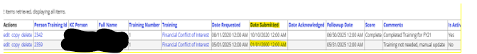

Notifications will not be activated for new users. They will need to successfully complete the tutorial prior to being able to spend their grant award.

Accessibility of Completion
All ORSP staff have access to the Person Training information in Kuali and can view all training records there, including follow-up dates. Note that Kuali will be updated after 10:00 am with any D2L activity from the prior afternoon/evening.

Other
In rare instances, individuals who are not Marquette University employees may still need to take the FCOI training. Guidance on handling these individuals is forthcoming.

For audit purposes, no students will be deleted from D2L and no Person Training data will be deleted from Kuali. There is no limit on enrollment and thus no purpose to delete students.

The Executive Director of the Office of Research and Sponsored programs or their designee and the ORSP liaison from the Office of General Counsel will review the training curriculum content at a minimum of every four years or more frequently if there is a change to federal regulations that require a change to the training. The programming of the tutorial was developed by the Center for Teaching and Learning (CTL). If there are any issues with the course content or D2L platform, please reach out to the Executive Director of ORSP as a first step.

